**HI-TEC ELECTRONIC SUPPLY LTD**

**Warehouse Management System**

Project Proposal

Prepared for:

**Nelson Eng, Instructor**

CSIS 3275 002 – Software Engineering

Development Team

**Matthew Lai**

**Manjot Sangha**

**Manveer Sidhu**

**Curtis Windsor**

**Sam Zhou**

**SUMMARY & SCOPE**

This document serves as a software requirements specification for HI-TEC Electronic Supply Ltd., a fictional business-to-business supplier that operates in the Lower Mainland; dealing primarily in individual computer components as well as complete pre-built machines. The software system in question is a management system for the company’s warehouse; tracking current stock, incoming orders, and outgoing shipments. This system is comprised primarily of: 1) A mySQL Database, 2) A website for clients, and 3) A program for employees.

The ultimate **objective** of this project is to create a comprehensive system for managing the movement of products in the warehouse.

**Deliverables** of this project will be:

1. A database complete with data
2. A fully-functional website with read-only capability from the database
3. A fully-functional application written in C# with different GUIs for specific departments
4. A comprehensive technical manual for the end user detailing the use of each module of the system
5. A detailed documentation log for programmers designed to assist in the system’s upkeep

**Technical** requirements of this system include:

1. A server running a LAMP stack
2. All machines running the application must have:
   1. Windows 7 and above
   2. 1 gigahertz (GHz) or faster 32-bit (x86) or 64-bit (x64) processor
   3. 1 gigabyte (GB) RAM (32-bit) or 2 GB RAM (64-bit)
   4. 16 GB available hard disk space (32-bit) or 20 GB (64-bit)
   5. DirectX 9 graphics device with WDDM 1.0 or higher driver
   6. Internet Access

**Limitations** of this software system include:

1. The system assumes there are already separate systems in place for Sales, Accounting, and so forth to handle issues such as payment processing.
2. Due to the warehouse focus of the system, the components that deal with orders and shipments exists solely to track inventory inputs and outputs.
3. Inventory inputs and outputs are entered into the system via the application when the appropriate waybill is received.

The development team for this system project consists of the following people with the following primary areas of responsibility. Despite this, it is projected that team members will assist each other in differing areas as required.

**Project Management:** Matthew Lai

**Website Design:** Manjot Sangha and Manveer Sidhu

**Software Programming:** Sam Zhou

**Server Administration:** Curtis Windsor

**COMPONENTS & TECHNOLOGIES**

**Component A – MySQL Database**

This will store the information needed to track our products in the warehouse. An ERD is available in the appendix of this document. (Fig. I)

**CA** - Technologies Involved:

* MySQL
* phpMyAdmin

**CA** - Development Tools:

* AWS EC2
  + Linux – Ubuntu 15.04
  + Apache
  + Cloud software specifications:
    - 1 gigahertz (GHz) or faster 32-bit (x86) or 64-bit (x64) processor
    - 1 gigabyte (GB) RAM (32-bit) or 2 GB RAM (64-bit)
    - 16 GB available hard disk space (32-bit) or 20 GB (64-bit)
    - DirectX 9 graphics device with WDDM 1.0 or higher driver
* MySQL Workbench 6.3 CE
* Mockaroo

**Component B – Client Website**

This displays information about our warehouse inventory for use by clients. This is necessary for our system as it assumes clients order products by phone only.

**CB** - Features and Functions:

* The user can view our stock, with the following product information displayed:
  + SKU
  + Name
  + Price
  + Manufacturer
  + Category
  + Image
* The user will be able to filter the displayed products by:
  + Product Category
  + Product Manufacturer
* The user will be able to search for a specific product by:
  + Product SKU
  + Product Name
* All the above display results can be ordered by price ascending/descending
* A contact form for clients who want more information will be provided

**CB** - Technologies Involved:

* HTML
* JavaScript
* AJAX
* PHP
* CSS
* Bootstrap

**CB** - Development Tools:

* Adobe Dreamweaver
* Codelobster
* FileZilla
* AWS EC2
  + Linux – Ubuntu 15.04
  + Apache
  + Cloud software specifications:
    - 1 gigahertz (GHz) or faster 32-bit (x86) or 64-bit (x64) processor
    - 1 gigabyte (GB) RAM (32-bit) or 2 GB RAM (64-bit)
    - 16 GB available hard disk space (32-bit) or 20 GB (64-bit)
    - DirectX 9 graphics device with WDDM 1.0 or higher driver

**Component C** **– Staff Application**

This program allows warehouse staff to manipulate the information stored in the database as products are moved around. For security reasons, different functions of the program are locked to an employee’s permission group.

**CC** - Features and Functions:

* A main login screen (Fig. II) that will prompt the user for their credentials. Depending on the permissions the user has access to; the relevant UI will then appear. The current permission groups are:
  + Warehouse Employee
  + Receiving Clerk
  + Shipping Employee
  + Operations Supervisor
  + Manager
  + Administrator
* An inventory checker UI (Fig. III) with read-only capability to the DB. For regular warehouse employees, this is their primary screen.
* A receiving UI (Fig. IV) with write access to the DB. This interface is for employees who deal with incoming products to the warehouse. As such, it has the functionality to update and add new records to the DB.
* A shipping UI (Fig. V) with write access to the DB. This interface is for employees who deal with outgoing products to clients. As such, it will have the functionality to update records to the DB.
  + Employees can create a new shipment whose information, including the associated products, are stored to the DB. Until the shipment is actually shipped however, the products are not yet deducted from the inventory stock.
  + Shipping employees can then go through the list of shipments that have yet to ship and mark them as ‘Shipped’, and only then are the products removed from the inventory. If the inventory does not contain enough of a product the user will be notified.
* A warehouse history log (Fig. VI), which will show all the shipment and order information that has occurred.

**CC** – Technologies Involved:

* C#

**CC** – Development Tools:

* Microsoft Visual Studio 2015
* Microsoft Visual Studio 2012 Express

**Non-Component Tools**

Additionally, the following services and tools will be used in order to provide version control and documentation throughout the entire development process, regardless of module.

* Git through Github
* SourceTree

**TIMELINE**

|  |  |
| --- | --- |
| WEEK | TASK(S) |
| 8 | * Application GUI design * Application login function * Server set-up * DB data importation * Website page layouts |
| 9 | * Application UI implementation * Website display functions |
| 10 | * Application UI linkage * Website display functions * Website contact form |
| 11 | * Application testing * Website CSS * Website function testing |
| 12 | * Final systems testing * Technical manual and documentation check * Presentation |

**APPENDIX**

Figure I: Database ERD

Figure II: Application Login UI

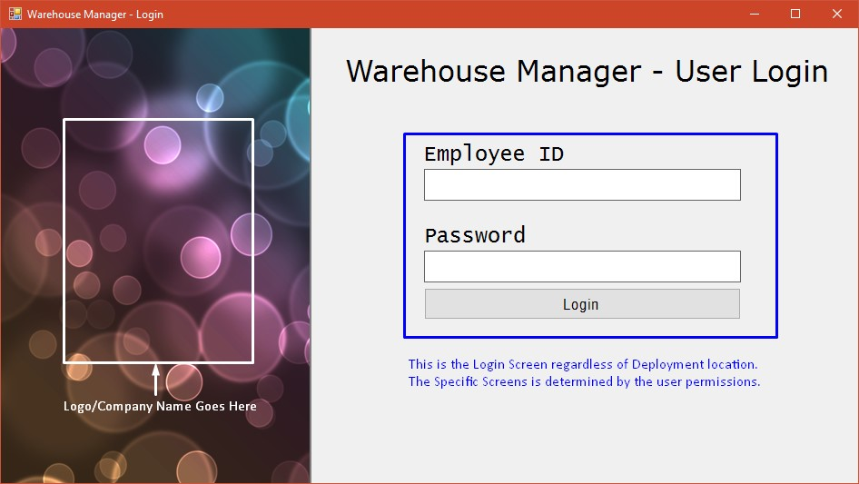

Figure III: Application Inventory UI

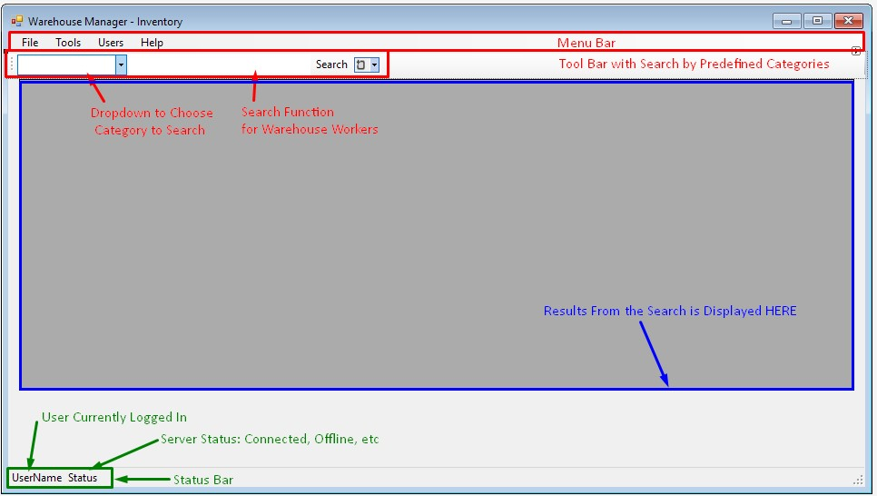

Figure IV: Application Receiving UI

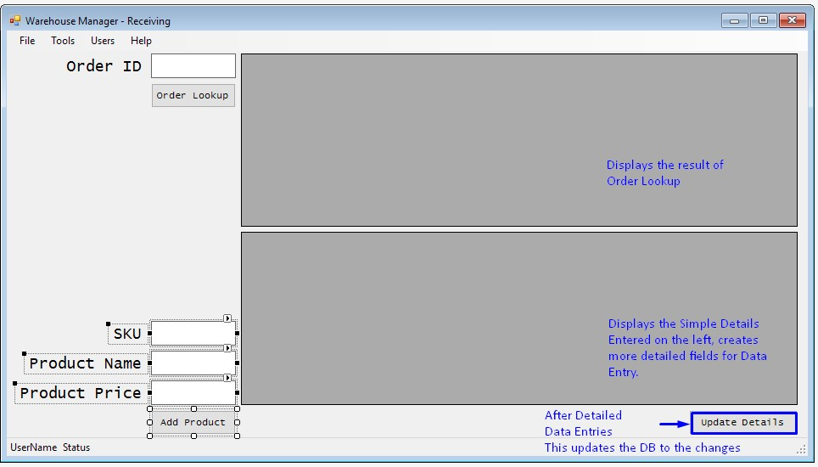

Figure V: Application Shipping UI

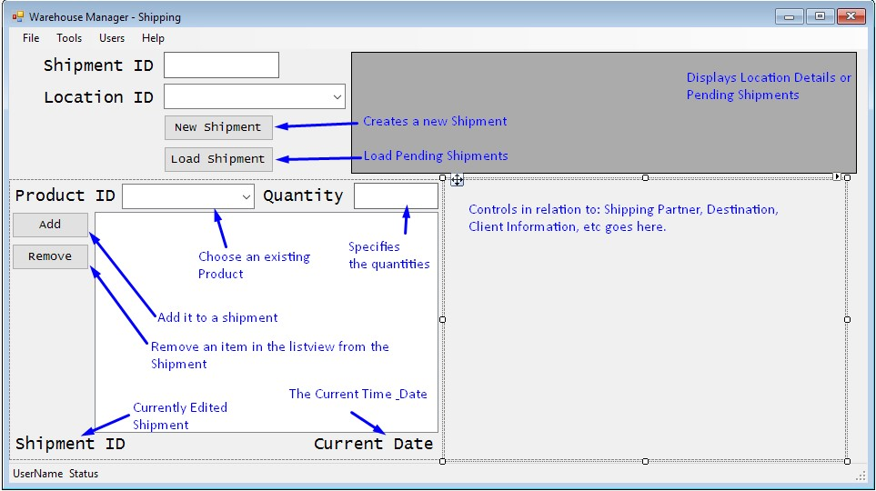

Figure VI: Application History UI

